Bad Design 1: Confusing Remote Control

Name: Gowdham B Regno: 23MIS0300
Subject: UI/UX Design

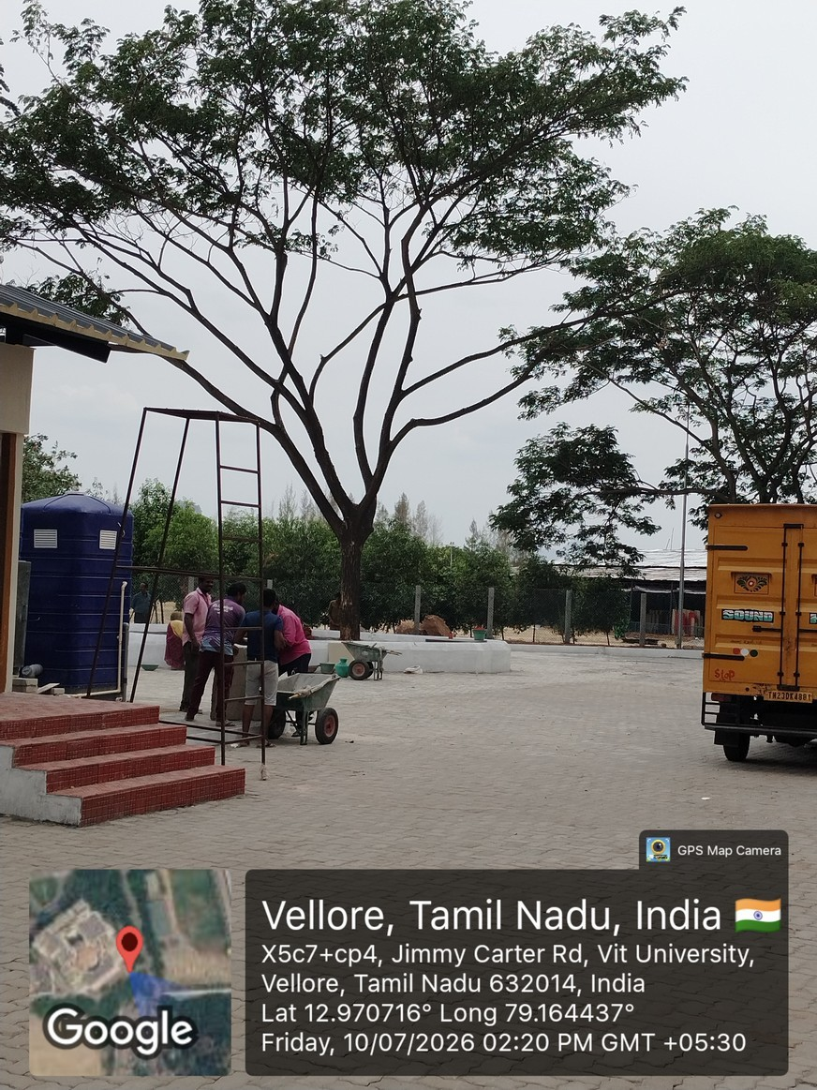
Pic1)
Description:
The tree that has been planted in the parking lot is in pathway, so that the students and faculty are finding difficulty in parking their vehicle.

Place:
11th gate of VIT

Reasons why the design is bad:
- The tree is not placed at either side of the parking.
- Since it has been placed in the middle of the parking lot, a particular amount of space is being wasted.

- Displace the tree somewhere else so that it doesn’t disturb the parking area.

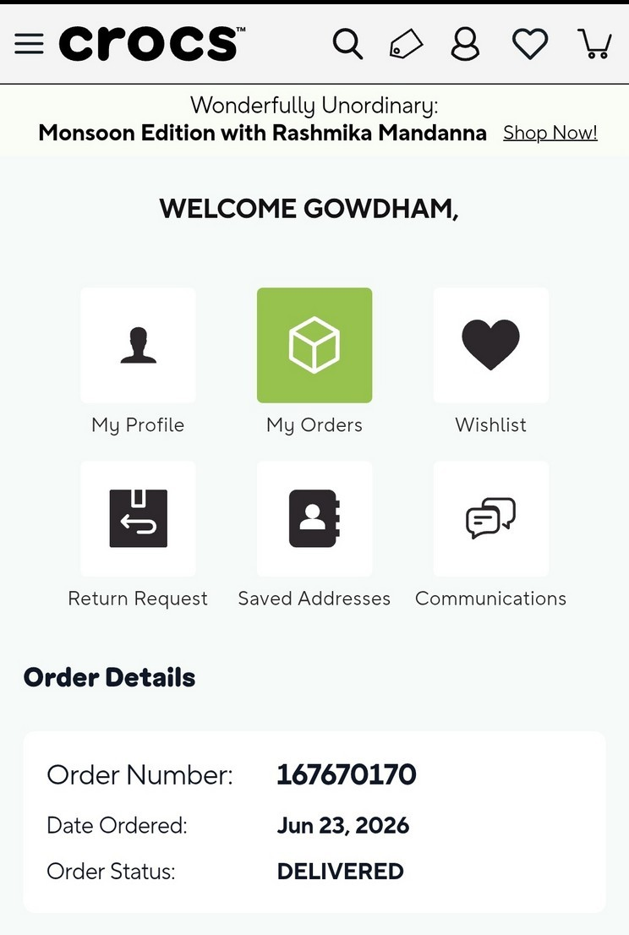
Pic2)

Description:
Once the order is placed, the customer is not notified properly about the product tracking and shipments. Only one or two emails regarding the confirmation of the order has been received by the customer.

Place:
Crocs.com

Reasons why the design is bad:
- When the order is placed, the tracking details aren’t described or mentioned anywhere in the site.
- Only the order confirmation is received, and the shipment is notified only at the day of delivery not before that.

- Add the shipment tracking feature so that the customer can track the order whenever they want to.

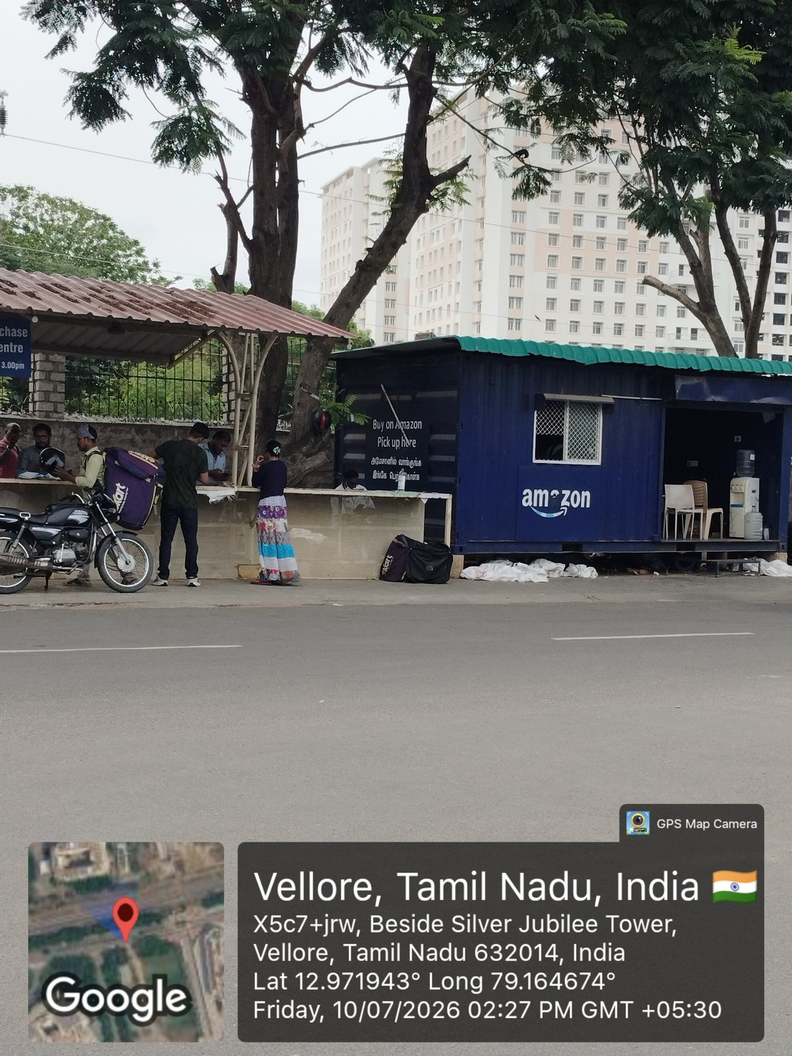
Pic3)
Description:
While collecting the order, the students find it difficult to find their delivery partner and no proper instruction is mentioned anywhere in that place to notify about collecting the order.

Place:
SJT parking area

Reasons why the design is bad:
- Instruction for collecting the order for students is not mentioned clearly, so that the students find it difficult to find their respective delivery partner.
- Since more online platforms exist, find which delivery area where it is located is tough.

Suggested Improvement:
- A notice board can be arranged and notice mentioning the place of where the delivery partner is and contact of the delivery partner can be mentioned.

Pic4)
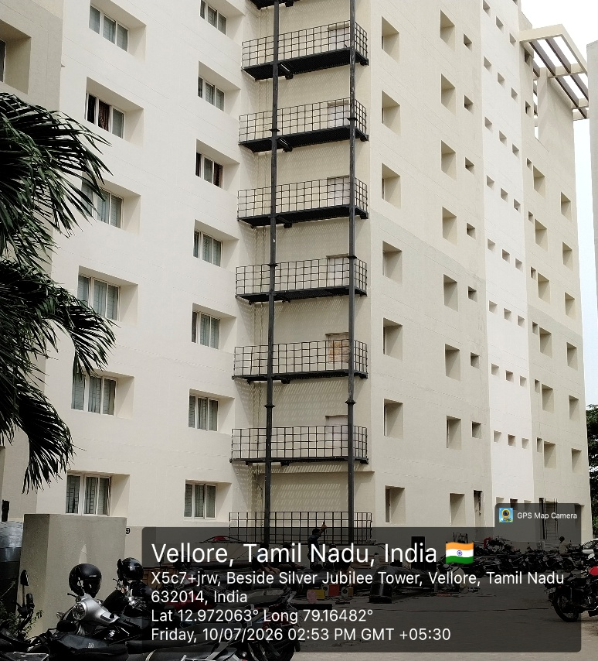

Description:
The metal/steel work in the building is of no use to any of the people, it is kind of a disturbance.

Place:
Near SJT Annex

Reasons why the design is bad:
- It doesn’t help to be useful, like the existence doesn’t add any value to the people around/maintenance people.

Suggested Improvement:
- Stairs can be implemented so that the people who are responsible for the maintenance can be effectively do their works.

Pic5)
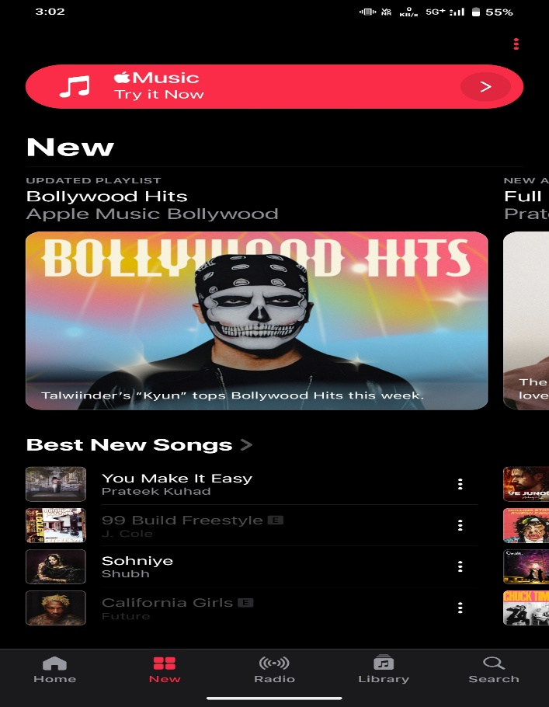

Description:
Using other music applications is much easier and better because of the better usability, ease of use but using apple music is a bit complicated as searching for playlist and songs aren’t as much as easier in comparison to any other music application.

Place:
Apple music.

Reasons why the design is bad:
People use the music ui very less as they’re travelling or walking and they need some music to hear, at that time the user may feel it hard to use apple music as finding a song or a playlist which someone has already created is very complicated.

Suggested Improvement:
Maybe the UI/UX can be re-designed so that searching for other playlists can be much easier to do.

